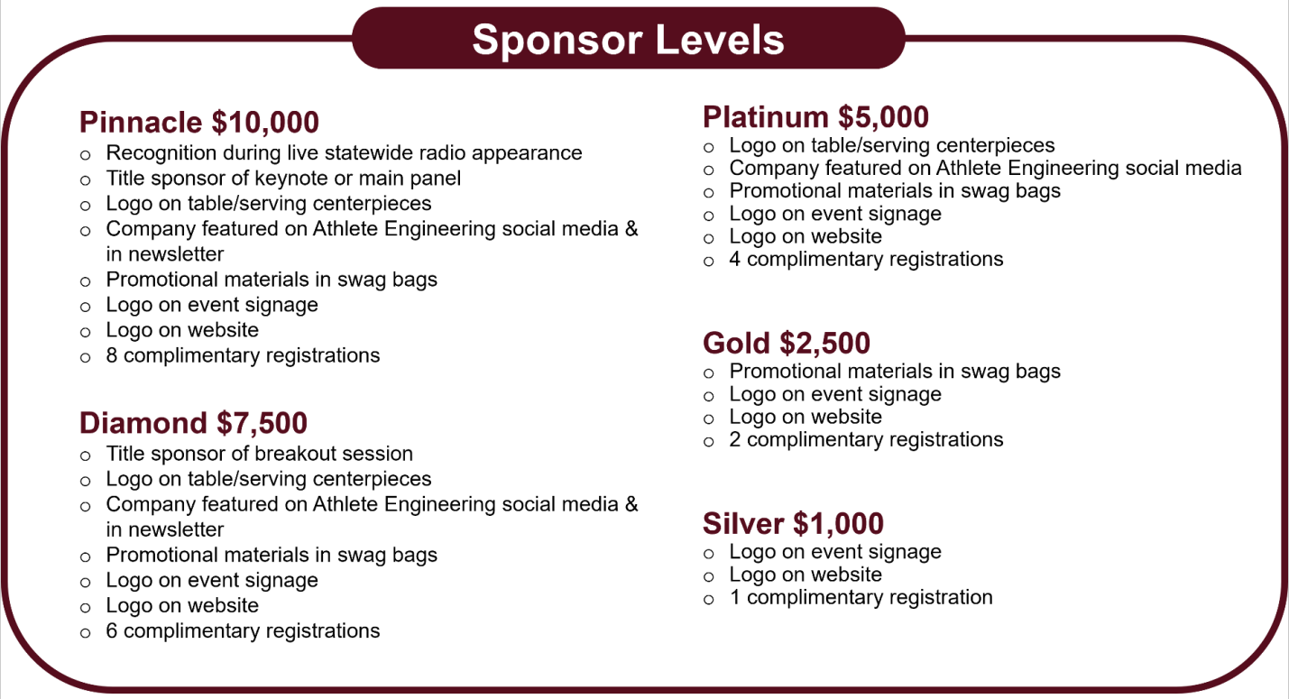

**2023: Speaking the**

**Same Language**